BARN THEATRE 39 STEPS – PROBUS VISIT TUESDAY 16TH JULY 2019
A cast of four deftly take on a Hitchcock classic in a wonderfully inventive comic-thriller parody adaption of John Buchan’s 1915 novel.
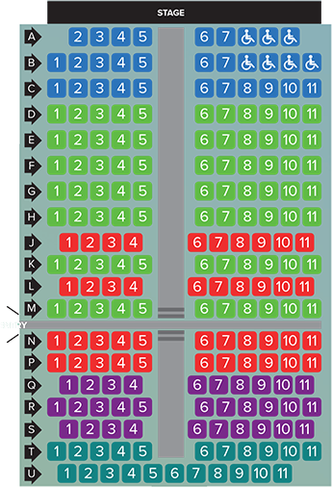
ZONE ‘B’ – Rows D, E, F, G, H, K & M
Normal concession price £22.50. Price to us if we can raise 25 or more £16.50

