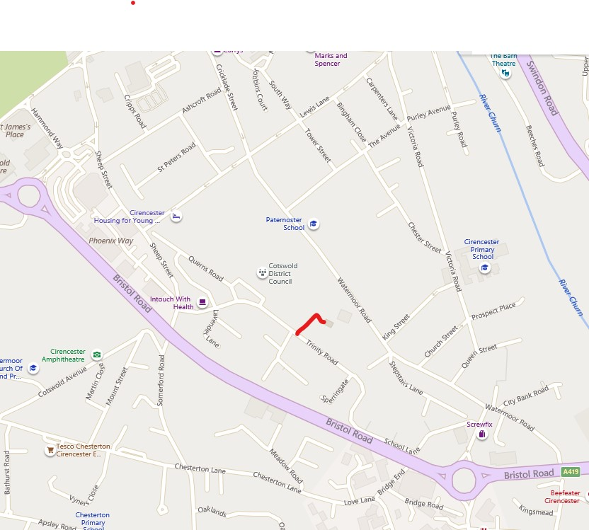
Watermoor Church Hall
Watermoor Church Hall

From Town Centre – Turn into Trinity Road and just past the Council Offices, there is a small lane on the left which brings you to the Hall
From the Fire Station Roundabout – take the first left past KwikFit into School Lane which winds round and becomes Trinity Road. You will see a school playing field on the right, and the lane into the Hall is on the right at the end of the playing field.

